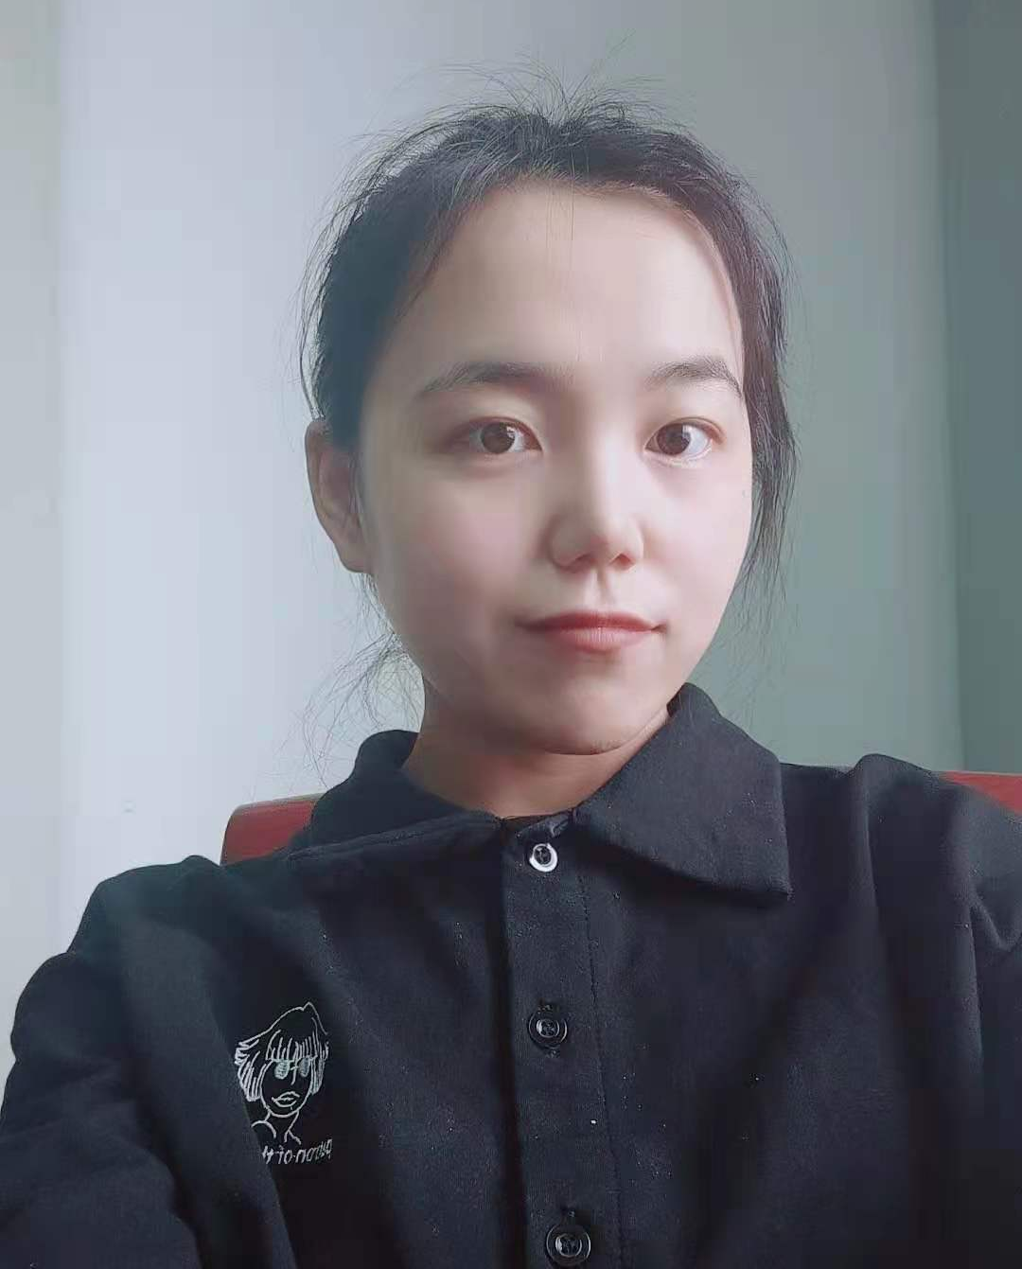

Curriculum Vitae

Contact information
Name： Lijian Zhang
Address： Kunming Institute of Botany,
Chinese Academy of Sciences ;

Lanhei Road 132, 650201 Kunming, Yunnan Province , China
Email： zhanglijianxn@163.com
Tel： 17782601602
Major
Biochemistry and Molecular Biology

Education
2021.09-Now | Ph.D Biochemistry and Molecular Biology | Kunming Institute of Botany, Chinese  Academy of Sciences; Kunming, China,
2016.09-2019.07 | M.S. Biochemistry and Molecular Biology | College of Life Science, Northwest A&F University; Yangling, China.
2012.09-2016.07 | B.S. Biotechnology | College of Life Science, Northeast Agricultural University; Haerbin, China.

